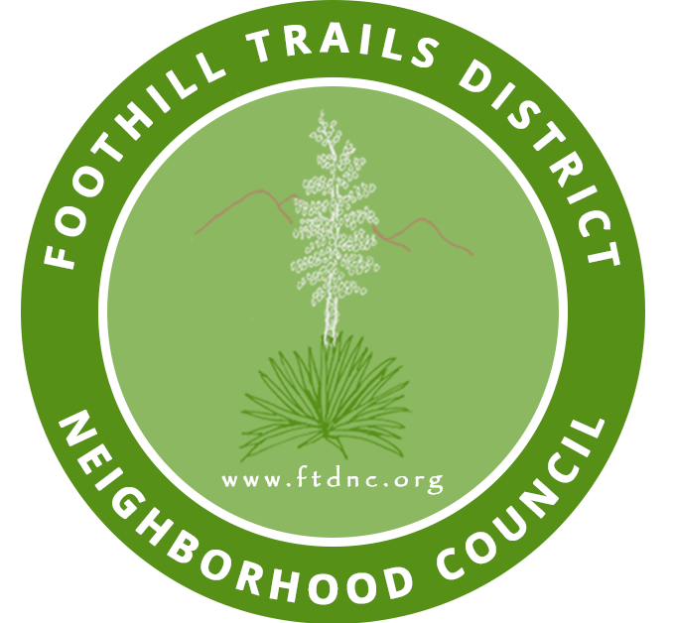Alisa Clairet Julie Battaglia Whiteman Airport Ad-Hoc Committee:

Cindy Bloom Kevin J Davis Eli Wells - Chair
Daniel Davis Oma El Cindy Bloom
Eli Wells Ryan Davis Tiser Turner
Jack Badossian Scott Froschauer Alisa Clairet
Josie Zarate |  | Tiser Turner |  | Josie Zarate
Judi Trujillo |  | Tricia Gilliken

FOOTHILL TRAILS DISTRICT NEIGHBORHOOD COUNCIL
SPECIAL WHITEMAN AIRPORT COMMITTEE MEETING AGENDA
January 26, 2022, 7:00 PM TO 9:00 PM
(The FTDNC Whiteman Airport Ad-Hoc Committee is scheduled for the Fourth Wednesday of the month.)
Zoom Meeting Online or by Telephone:
Dial (669) 900-9128 to Join the meeting then enter this
Webinar ID: 859 9237 3204
Online Zoom Meeting Link:

https://us02web.zoom.us/j/85992373204
IN CONFORMITY WITH THE SEPTEMBER 16, 2021 ENACTMENT OF CALIFORNIA ASSEMBLY BILL 361 (RIVAS) AND DUE TO CONCERNS OVER COVID-19, THE FTDNC WHITEMAN AIRPORT COMMITTEE MEETING WILL BE CONDUCTED ENTIRELY WITH A CALL-IN OPTION OR INTERNET-BASED SERVICE OPTION.

ACCESSING THE MEETING: Every person wishing to address the Committee must dial (669) 900-9128, and enter the nine-digit meeting code listed above and then press# to join the meeting, or use the online link. Instructions on how to sign up for public comment will be given to listeners at the start of the meeting.
- Call to order, Pledge of Allegiance
- Welcome to new stakeholders wishing to join the Whiteman Airport Ad-Hoc Committee
- Comments by Public Representatives
a) Anthony Espinosa – CD7 Status of Airport and position on Closure
What is the main stated official reason or reasons for the decision to close.
b) Congressman Tony Cardenas communication – email to rep. Lilia Monterossa regarding specific detail information requested of FAA reports regarding activity etc. at Whiteman Airport requested by his Office.
c) Discuss Times article re: Board of Supervisor Kuehl request for FAA Data
- Public Comment – (3 minutes each, non-agenda items only)
a) Recap history of the Whiteman Airport Revisioning
  - Items from the floor
- Updates Whiteman Airport Plane Crash (1/9/2022):
  - Recap of LAPD Foothill Division update given by Captain Smith on 1/13/2022
- Additional Old/New items of note
- Committee member comments
- Approval of prior meeting draft minutes
- Set date of next Land Use Committee meeting – February 23, 2022
- Adjournment

PROCESS FOR RECONSIDERATION - For information on the FTDNC’s process for board action reconsideration, stakeholder grievance policy, or any other procedural matters related to this Council, please consult the FTDNC Bylaws at FTDNC.org .
PUBLIC INPUT AT NEIGHBORHOOD COUNCIL MEETINGS – The public is requested to fill out a “Speaker Card” to address board members on any agenda item before they take a formal position at any meeting. Comments from the public on agenda items will be heard only when the respective item is being considered. Comments from the public on other matters not appearing on the agenda that are within the Council’s jurisdiction will be heard during the Public Comment period. Please note that under the Brown Act, the Board may be prevented from acting on a matter that you bring to its attention during the Public Comment period. However, any issue raised by a speaker may become the subject of a future meeting. Public comment is limited to 2 minutes per speaker, but limited time extensions may be granted by the Chairperson in consultation with other board members present.
THE AMERICAN WITH DISABILITIES ACT - As a covered entity under Title II of the Americans with Disabilities Act, the City of Los Angeles does not discriminate on the basis of disability and, upon request, will provide reasonable accommodation to ensure equal access to its programs, services and activities. Sign language interpreters, assistive listening devices and other auxiliary aids and/or services, may be provided upon request. To ensure availability of services, please make your request at least 7 calendar days prior to the meeting you wish to attend by contacting Kevin J. Davis, Board President via email at president@ftdnc.org.
TRANSLATION SERVICES - To ensure availability of services or to request translation, please make your request at least 7 calendar days prior to the meeting you wish to attend by contacting Kevin J. Davis, Board President via email at president@ftdnc.org.
SERVICIOS DE TRADUCCION - Si requiere servicios de traducción, favor de avisar al Concejo Vecinal 7 días de trabajo antes del evento. Por favor contacte a Kevin J. Davis, Presidente por correo electrónico president@ftdnc.org. para avisar al Concejo Vecinal.
PUBLIC ACCESS TO MEETING DOCUMENTS - Agendas are posted for public review at the FTDNC Headquarters, 9747 Wheatland Avenue, Shadow Hills, CA and on the FTDNC.org webpage. You can also receive agendas via email by sending a request to be added to FTDNC email blast to foothilltrails@gmail.com and/or by subscribing to the City’s Early Notification System at https://www.lacity.org/your-government/councilvotes/subscribe-meeting-agendas/neighborhood-councils.

AB 361 UPDATES - Public comment cannot be required to be submitted in advance of the meeting, only real-time public comment is required. If there are any broadcasting interruptions that prevent the public from observing or hearing the meeting, the meeting must be recessed or adjourned. If members of the public are unable to provide public comment or be heard due to issues within the Neighborhood Council’s control, the meeting must be recessed or adjourned.

NOTICE TO PAID REPRESENTATIVES - If you are compensated to monitor, attend, or speak at this meeting, City law may require you to register as a lobbyist and report your activity. See Los Angeles Municipal Code Section 48.01 et seq. More information is available at ethics.lacity.org/lobbying. For assistance, please contact the Ethics Commission at (213) 978-1960 or ethics.commission@lacity.org
In compliance with Government Code section 54957.5, non-exempt writings that are distributed to a majority or all of the board in advance of a meeting may be viewed at our website: FTDNC.org or at the scheduled meeting. In addition, if you would like a copy of any record related to an item on the agenda, please contact Kevin J. Davis, Board President via email at president@ftdnc.org
1.

